Parameters Section

""""""""""""""""""""""""""""""""""""""""""""""""""""""""""""""""""""""""""

RMS Prop:

num_epochs = 5

csv_file = 'winequality-white.csv'

num_cols = 11

num_cols_after = 11

layer1_nodes = [25, 40, 75, 150]

layer2_nodes = [0, 15, 35]

act_function = 'relu'

optimizer = 'RMSprop'

set_verbose = 2

Epoch 1/5

123/123 - 1s - loss: 1.3602 - accuracy: 0.4620 - val_loss: 1.1903 - val_accuracy: 0.5194

Epoch 2/5

123/123 - 1s - loss: 1.1934 - accuracy: 0.5000 - val_loss: 1.1518 - val_accuracy: 0.5031

Epoch 3/5

123/123 - 1s - loss: 1.1593 - accuracy: 0.5130 - val_loss: 1.1191 - val_accuracy: 0.5357

Epoch 4/5

123/123 - 1s - loss: 1.1430 - accuracy: 0.5143 - val_loss: 1.1197 - val_accuracy: 0.5235

Epoch 5/5

123/123 - 1s - loss: 1.1327 - accuracy: 0.5184 - val_loss: 1.1007 - val_accuracy: 0.5490

Time required for training: 0:00:45.169948

‘’’’’’’’’’’’’’’’’’’’’’’’’’’’’’’’’’’’’’’’’’’’’’’’’’’’’’’’’’’’’’’’’’’’’’’’’’’’’’’’’’’’’’’’’’’’’’’’’’’’’’’’’’’’’’’’’’’’’’’’’

Parameters Section

"""""""""""""""""""""""""""""""""""""""""""""""""""""""""""""""""""""""""""

layer1_nodes = [7,14,28,102]

layer2_nodes = [0,7,25,55]

layer3_nodes = [0,7,18]

Epoch 1/6

123/123 - 1s - loss: 1.4735 - accuracy: 0.4405 - val_loss: 1.2856 - val_accuracy: 0.4459

Epoch 2/6

123/123 - 1s - loss: 1.2388 - accuracy: 0.4890 - val_loss: 1.2180 - val_accuracy: 0.4888

Epoch 3/6

123/123 - 1s - loss: 1.1920 - accuracy: 0.5089 - val_loss: 1.1891 - val_accuracy: 0.5031

Epoch 4/6

123/123 - 1s - loss: 1.1679 - accuracy: 0.5130 - val_loss: 1.1645 - val_accuracy: 0.5173

Epoch 5/6

123/123 - 1s - loss: 1.1503 - accuracy: 0.5174 - val_loss: 1.1561 - val_accuracy: 0.5051

Epoch 6/6

123/123 - 1s - loss: 1.1376 - accuracy: 0.5253 - val_loss: 1.1487 - val_accuracy: 0.5071

Time required for training: 0:01:29.436070

‘’’’’’’’’’’’

num_epochs = 5

csv_file = 'winequality-white.csv'

num_cols = 11

num_cols_after = 11

layer1_nodes = [25, 40, 75, 150]

layer2_nodes = [0, 15, 35]

layer3_nodes = [0,15]

act_function = 'relu'

optimizer = 'RMSprop'

set_verbose = 2

Epoch 1/5

123/123 - 1s - loss: 1.3633 - accuracy: 0.4541 - val_loss: 1.2151 - val_accuracy: 0.4643

Epoch 2/5

123/123 - 1s - loss: 1.1850 - accuracy: 0.4934 - val_loss: 1.1710 - val_accuracy: 0.5010

Epoch 3/5

123/123 - 1s - loss: 1.1547 - accuracy: 0.5110 - val_loss: 1.1694 - val_accuracy: 0.4949

Epoch 4/5

123/123 - 1s - loss: 1.1435 - accuracy: 0.5174 - val_loss: 1.1431 - val_accuracy: 0.5071

Epoch 5/5

123/123 - 1s - loss: 1.1300 - accuracy: 0.5235 - val_loss: 1.1354 - val_accuracy: 0.5173

Time required for training: 0:00:38.312242

‘’’’’’’’’’’’’’’’’’’’’’’’’’’’’’’’’’’’’’’’’’’’’’’’’’’’’’’’’’’’’’’’’’’’’’’’’’’’’’’’’’’’’’’’’’’’’’’’’’’’’’’’’’’’’’’’’’’’’’’’’’’’’’’’’’’’’’

num_epochs = 5

csv_file = 'winequality-white.csv'

num_cols = 11

num_cols_after = 11

layer1_nodes = [111, 122, 143, 152]

layer2_nodes = [0, 11, 21]

layer3_nodes = [0,11]

act_function = 'relu'

optimizer = 'RMSprop'

set_verbose = 2

Epoch 1/5

123/123 - 1s - loss: 1.5490 - accuracy: 0.4472 - val_loss: 1.3357 - val_accuracy: 0.4398

Epoch 2/5

123/123 - 1s - loss: 1.2689 - accuracy: 0.4528 - val_loss: 1.2481 - val_accuracy: 0.4531

Epoch 3/5

123/123 - 1s - loss: 1.2217 - accuracy: 0.4750 - val_loss: 1.2176 - val_accuracy: 0.4755

Epoch 4/5

123/123 - 1s - loss: 1.1955 - accuracy: 0.4992 - val_loss: 1.1957 - val_accuracy: 0.4939

Epoch 5/5

123/123 - 1s - loss: 1.1784 - accuracy: 0.5087 - val_loss: 1.1855 - val_accuracy: 0.4898

Time required for training: 0:00:40.584944

‘’’’

num_epochs = 5

csv_file = 'winequality-white.csv'

num_cols = 11

num_cols_after = 11

layer1_nodes = [163, 177, 191, 205]

layer2_nodes = [0, 14, 28]

layer3_nodes = [0,14]

act_function = 'relu'

optimizer = 'RMSprop'

set_verbose = 2

Epoch 1/5

123/123 - 1s - loss: 1.6353 - accuracy: 0.4091 - val_loss: 1.3783 - val_accuracy: 0.4398

Epoch 2/5

123/123 - 1s - loss: 1.3021 - accuracy: 0.4510 - val_loss: 1.2834 - val_accuracy: 0.4378

Epoch 3/5

123/123 - 1s - loss: 1.2467 - accuracy: 0.4530 - val_loss: 1.2380 - val_accuracy: 0.4398

Epoch 4/5

123/123 - 1s - loss: 1.2123 - accuracy: 0.4706 - val_loss: 1.2088 - val_accuracy: 0.4796

Epoch 5/5

123/123 - 1s - loss: 1.1881 - accuracy: 0.4926 - val_loss: 1.1895 - val_accuracy: 0.4949

Time required for training: 0:00:41.552831

‘’’’’’’

"""""""""""""""""""""""""""""""""""""""""""""""""""""""""""""""""""""""""""

Parameters Section

"""""""""""""""""""""""""""""""""""""""""""""""""""""""""""""""""""""""""""

num_epochs = 5

csv_file = 'winequality-white.csv'

num_cols = 11

num_cols_after = 11

layer1_nodes = [14,20,45,99,186]

layer2_nodes = [0,7,25,54]

layer3_nodes = [0,7,21]

act_function = 'relu'

optimizer = 'RMSprop'

set_verbose = 2

Epoch 1/5

123/123 - 1s - loss: 1.5314 - accuracy: 0.4321 - val_loss: 1.3051 - val_accuracy: 0.4398

Epoch 2/5

123/123 - 1s - loss: 1.2620 - accuracy: 0.4684 - val_loss: 1.2382 - val_accuracy: 0.4694

Epoch 3/5

123/123 - 1s - loss: 1.2180 - accuracy: 0.4969 - val_loss: 1.2092 - val_accuracy: 0.4857

Epoch 4/5

123/123 - 1s - loss: 1.1889 - accuracy: 0.4995 - val_loss: 1.1868 - val_accuracy: 0.4857

Epoch 5/5

123/123 - 1s - loss: 1.1679 - accuracy: 0.5077 - val_loss: 1.1677 - val_accuracy: 0.5020

Time required for training: 0:01:08.112434

‘’’’’

Parameters Section

"""""""""""""""""""""""""""""""""""""""""""""""""""""""""""""""""""""""""""

num_epochs = 5

csv_file = 'winequality-white.csv'

num_cols = 11

num_cols_after = 11

layer1_nodes = [18,46,56,98]

layer2_nodes = [0,18,47,77]

layer3_nodes = [0,18]

act_function = 'relu'

optimizer = 'RMSprop'

set_verbose = 2

Epoch 1/5

123/123 - 1s - loss: 1.3894 - accuracy: 0.4510 - val_loss: 1.2464 - val_accuracy: 0.4918

Epoch 2/5

123/123 - 1s - loss: 1.2084 - accuracy: 0.4972 - val_loss: 1.1899 - val_accuracy: 0.4857

Epoch 3/5

123/123 - 1s - loss: 1.1724 - accuracy: 0.5092 - val_loss: 1.1667 - val_accuracy: 0.5051

Epoch 4/5

123/123 - 1s - loss: 1.1547 - accuracy: 0.5250 - val_loss: 1.1589 - val_accuracy: 0.5082

Epoch 5/5

123/123 - 1s - loss: 1.1433 - accuracy: 0.5232 - val_loss: 1.1450 - val_accuracy: 0.5153

Time required for training: 0:00:54.263191

‘’’’

num_epochs = 5

csv_file = 'winequality-white.csv'

num_cols = 11

num_cols_after = 11

layer1_nodes = [28,46,56,98]

layer2_nodes = [0,18,47,77]

layer3_nodes = [0,18]

#layer4_nodes = []

act_function = 'relu'

optimizer = 'RMSprop'

set_verbose = 2

Epoch 1/5

123/123 - 1s - loss: 1.5222 - accuracy: 0.4002 - val_loss: 1.3281 - val_accuracy: 0.4398

Epoch 2/5

123/123 - 1s - loss: 1.2608 - accuracy: 0.4525 - val_loss: 1.2283 - val_accuracy: 0.4510

Epoch 3/5

123/123 - 1s - loss: 1.1959 - accuracy: 0.4883 - val_loss: 1.1862 - val_accuracy: 0.5000

Epoch 4/5

123/123 - 1s - loss: 1.1669 - accuracy: 0.5079 - val_loss: 1.1683 - val_accuracy: 0.5061

Epoch 5/5

123/123 - 1s - loss: 1.1534 - accuracy: 0.5110 - val_loss: 1.1538 - val_accuracy: 0.5194

Time required for training: 0:00:53.832586

‘’’’’’’

num_epochs = 5

csv_file = 'winequality-white.csv'

num_cols = 11

num_cols_after = 11

layer1_nodes = [18,24,48,102]

layer2_nodes = [0,6,24,54]

layer3_nodes = [0,6,18]

Epoch 1/5

123/123 - 1s - loss: 1.5032 - accuracy: 0.4472 - val_loss: 1.3261 - val_accuracy: 0.4398

Epoch 2/5

123/123 - 1s - loss: 1.2913 - accuracy: 0.4510 - val_loss: 1.2805 - val_accuracy: 0.4398

Epoch 3/5

123/123 - 1s - loss: 1.2540 - accuracy: 0.4594 - val_loss: 1.2471 - val_accuracy: 0.4531

Epoch 4/5

123/123 - 1s - loss: 1.2242 - accuracy: 0.4809 - val_loss: 1.2188 - val_accuracy: 0.4980

Epoch 5/5

123/123 - 1s - loss: 1.2005 - accuracy: 0.5015 - val_loss: 1.2020 - val_accuracy: 0.4714

Time required for training: 0:00:53.857226

‘’’’’

Parameters Section

"""""""""""""""""""""""""""""""""""""""""""""""""""""""""""""""""""""""""""

num_epochs = 5

csv_file = 'winequality-white.csv'

num_cols = 11

num_cols_after = 11

layer1_nodes = [7,14,28,102]

layer2_nodes = [0,7,25,55]

layer3_nodes = [0,7,18]

#layer4_nodes =[0,0,11]

act_function = 'relu'

Epoch 1/5

123/123 - 1s - loss: 1.5787 - accuracy: 0.3548 - val_loss: 1.3367 - val_accuracy: 0.4602

Epoch 2/5

123/123 - 1s - loss: 1.2782 - accuracy: 0.4625 - val_loss: 1.2519 - val_accuracy: 0.4571

Epoch 3/5

123/123 - 1s - loss: 1.2247 - accuracy: 0.4921 - val_loss: 1.2083 - val_accuracy: 0.5020

Epoch 4/5

123/123 - 1s - loss: 1.1925 - accuracy: 0.5105 - val_loss: 1.1842 - val_accuracy: 0.5092

Epoch 5/5

123/123 - 1s - loss: 1.1714 - accuracy: 0.5153 - val_loss: 1.1639 - val_accuracy: 0.5133

Time required for training: 0:00:54.718402

NADAM

import datetime

import numpy as np

import pandas as pd

from tensorflow import keras

from tensorflow.keras.models import Sequential

from tensorflow.keras.layers import Dense

from matplotlib import pyplot

from sklearn.model_selection import train_test_split

from sklearn import preprocessing

from tensorflow.keras.utils import to_categorical

from sklearn.preprocessing import LabelEncoder

"""""""""""""""""""""""""""""""""""""""""""""""""""""""""""""""""""""""""""

Parameters Section

"""""""""""""""""""""""""""""""""""""""""""""""""""""""""""""""""""""""""""

num_epochs = 5

csv_file = 'winequality-white.csv'

num_cols = 11

num_cols_after = 11

layer1_nodes = [7,14,28,102]

layer2_nodes = [0,7,25,55]

layer3_nodes = [0,7,18]

#layer4_nodes =[0,0,11]

act_function = 'relu'

optimizer = 'Nadam'

set_verbose = 2

Epoch 1/5

123/123 - 2s - loss: 1.7070 - accuracy: 0.3737 - val_loss: 1.4192 - val_accuracy: 0.4398

Epoch 2/5

123/123 - 1s - loss: 1.3097 - accuracy: 0.4510 - val_loss: 1.2681 - val_accuracy: 0.4398

Epoch 3/5

123/123 - 1s - loss: 1.2299 - accuracy: 0.4587 - val_loss: 1.2185 - val_accuracy: 0.4878

Epoch 4/5

123/123 - 1s - loss: 1.1881 - accuracy: 0.4908 - val_loss: 1.1895 - val_accuracy: 0.4980

Epoch 5/5

123/123 - 1s - loss: 1.1618 - accuracy: 0.5133 - val_loss: 1.1635 - val_accuracy: 0.5235

Time required for training: 0:01:17.263570

‘’’

"""""""""""""""""""""""""""""""""""""""""""""""""""""""""""""""""""""""""""

Parameters Section

"""""""""""""""""""""""""""""""""""""""""""""""""""""""""""""""""""""""""""

num_epochs = 7

csv_file = 'winequality-white.csv'

num_cols = 11

num_cols_after = 11

layer1_nodes = [7,14,28,102]

layer2_nodes = [0,7]

#layer3_nodes = [0,7,18]

#layer4_nodes =[0,0,11]

act_function = 'relu'

optimizer = 'Nadam'

set_verbose = 2

//layers change to softmax***

Epoch 1/7

123/123 - 1s - loss: 1.5586 - accuracy: 0.4505 - val_loss: 1.3607 - val_accuracy: 0.4398

Epoch 2/7

123/123 - 1s - loss: 1.2653 - accuracy: 0.4661 - val_loss: 1.2330 - val_accuracy: 0.4776

Epoch 3/7

123/123 - 1s - loss: 1.2044 - accuracy: 0.5036 - val_loss: 1.2051 - val_accuracy: 0.4796

Epoch 4/7

123/123 - 1s - loss: 1.1786 - accuracy: 0.5148 - val_loss: 1.1802 - val_accuracy: 0.5163

Epoch 5/7

123/123 - 1s - loss: 1.1630 - accuracy: 0.5242 - val_loss: 1.1671 - val_accuracy: 0.5102

Epoch 6/7

123/123 - 1s - loss: 1.1517 - accuracy: 0.5299 - val_loss: 1.1600 - val_accuracy: 0.5143

Epoch 7/7

123/123 - 1s - loss: 1.1441 - accuracy: 0.5337 - val_loss: 1.1496 - val_accuracy: 0.5184

Time required for training: 0:00:46.677998

‘’’’’

num_epochs = 20

csv_file = 'winequality-white.csv'

num_cols = 11

num_cols_after = 11

layer1_nodes = [7,14,28,102]

layer2_nodes = [0,7,25,55]

layer3_nodes = [0,7,18]

#layer4_nodes =[0,7]

act_function = 'relu'

optimizer = 'Nadam'

set_verbose = 2

///

Epoch 1/10

123/123 - 1s - loss: 1.4429 - accuracy: 0.3877 - val_loss: 1.2595 - val_accuracy: 0.4388

Epoch 2/10

123/123 - 1s - loss: 1.2111 - accuracy: 0.4778 - val_loss: 1.1968 - val_accuracy: 0.4929

Epoch 3/10

123/123 - 1s - loss: 1.1719 - accuracy: 0.5018 - val_loss: 1.1718 - val_accuracy: 0.4929

Epoch 4/10

123/123 - 1s - loss: 1.1516 - accuracy: 0.5148 - val_loss: 1.1541 - val_accuracy: 0.5082

Epoch 5/10

123/123 - 1s - loss: 1.1380 - accuracy: 0.5199 - val_loss: 1.1494 - val_accuracy: 0.5133

Epoch 6/10

123/123 - 1s - loss: 1.1275 - accuracy: 0.5260 - val_loss: 1.1318 - val_accuracy: 0.5122

Epoch 7/10

123/123 - 1s - loss: 1.1180 - accuracy: 0.5253 - val_loss: 1.1247 - val_accuracy: 0.5143

Epoch 8/10

123/123 - 1s - loss: 1.1091 - accuracy: 0.5332 - val_loss: 1.1253 - val_accuracy: 0.5204

Epoch 9/10

123/123 - 1s - loss: 1.1049 - accuracy: 0.5345 - val_loss: 1.1149 - val_accuracy: 0.5153

Epoch 10/10

123/123 - 1s - loss: 1.0997 - accuracy: 0.5370 - val_loss: 1.1101 - val_accuracy: 0.5184

Time required for training: 0:02:18.930196

‘’’’

"""""""""""""""""""""""""""""""""""""""""""""""""""""""""""""""""""""""""""

Parameters Section

"""""""""""""""""""""""""""""""""""""""""""""""""""""""""""""""""""""""""""

num_epochs = 20

csv_file = 'winequality-white.csv'

num_cols = 11

num_cols_after = 11

layer1_nodes = [7,14,28,102]

layer2_nodes = [0,7,25,55]

layer3_nodes = [0,7,18]

#layer4_nodes =[0,7]

act_function = 'relu'

///activation output = sigmoid

optimizer = 'Nadam'

set_verbose = 2

Epoch 15/20

123/123 - 1s - loss: 1.0961 - accuracy: 0.5368 - val_loss: 1.1077 - val_accuracy: 0.5306

Epoch 16/20

123/123 - 1s - loss: 1.0929 - accuracy: 0.5447 - val_loss: 1.1114 - val_accuracy: 0.5265

Epoch 17/20

123/123 - 1s - loss: 1.0909 - accuracy: 0.5454 - val_loss: 1.1035 - val_accuracy: 0.5276

Epoch 18/20

123/123 - 1s - loss: 1.0871 - accuracy: 0.5416 - val_loss: 1.1050 - val_accuracy: 0.5276

Epoch 19/20

123/123 - 1s - loss: 1.0856 - accuracy: 0.5470 - val_loss: 1.1030 - val_accuracy: 0.5173

Epoch 20/20

123/123 - 1s - loss: 1.0825 - accuracy: 0.5480 - val_loss: 1.0986 - val_accuracy: 0.5337

Time required for training: 0:04:30.310101

‘’’’’’’’’’’

num_epochs = 10

csv_file = 'winequality-white.csv'

num_cols = 11

num_cols_after = 11

layer1_nodes = [7,14,28,102]

layer2_nodes = [0,7,25,55]

layer3_nodes = [0,7,18]

layer4_nodes =[0,7]

act_function = 'relu'

optimizer = 'Nadam'

set_verbose = 2

/// sigmoid output

123/123 - 1s - loss: 1.1206 - accuracy: 0.5296 - val_loss: 1.1254 - val_accuracy: 0.5143

Epoch 8/10

123/123 - 1s - loss: 1.1137 - accuracy: 0.5337 - val_loss: 1.1177 - val_accuracy: 0.5306

Epoch 9/10

123/123 - 1s - loss: 1.1091 - accuracy: 0.5393 - val_loss: 1.1148 - val_accuracy: 0.5316

Epoch 10/10

123/123 - 1s - loss: 1.1049 - accuracy: 0.5368 - val_loss: 1.1191 - val_accuracy: 0.5122

Time required for training: 0:02:21.521041

‘’’’’

Original parameters but deep layers

num_epochs = 10

csv_file = 'winequality-white.csv'

num_cols = 11

num_cols_after = 11

layer1_nodes = [25,40,75,150]

layer2_nodes = [0,15,35,60]

layer3_nodes = [0,15,35]

layer4_nodes =[0,15]

act_function = 'relu'

optimizer = 'Nadam'

set_verbose = 2

//sigmoid output

Epoch 7/10

123/123 - 1s - loss: 1.1169 - accuracy: 0.5352 - val_loss: 1.1200 - val_accuracy: 0.5235

Epoch 8/10

123/123 - 1s - loss: 1.1107 - accuracy: 0.5375 - val_loss: 1.1163 - val_accuracy: 0.5235

Epoch 9/10

123/123 - 1s - loss: 1.1055 - accuracy: 0.5350 - val_loss: 1.1168 - val_accuracy: 0.5184

Epoch 10/10

123/123 - 1s - loss: 1.1014 - accuracy: 0.5385 - val_loss: 1.1097 - val_accuracy: 0.5184

Time required for training: 0:02:19.549784

‘’’’’

num_epochs = 10

csv_file = 'winequality-white.csv'

num_cols = 11

num_cols_after = 11

layer1_nodes = [25,40,75,165]

layer2_nodes = [0,15,35,85]

layer3_nodes = [0,15,35]

layer4_nodes =[0,15]

act_function = 'relu'

optimizer = 'Nadam'

set_verbose = 2

Epoch 8/10

123/123 - 1s - loss: 1.1148 - accuracy: 0.5294 - val_loss: 1.1209 - val_accuracy: 0.5296

Epoch 9/10

123/123 - 1s - loss: 1.1087 - accuracy: 0.5350 - val_loss: 1.1171 - val_accuracy: 0.5122

Epoch 10/10

123/123 - 1s - loss: 1.1037 - accuracy: 0.5281 - val_loss: 1.1094 - val_accuracy: 0.5245

Time required for training: 0:02:18.890939

**optimal Model?***

num_epochs = 50

csv_file = 'winequality-white.csv'

num_cols = 11

num_cols_after = 11

layer1_nodes = [25, 40, 75, 150]

layer2_nodes = [0, 15, 35]

layer3_nodes = [0,15]

act_function = 'relu'

activation2='sigmoid'

optimizer='Nadam'

set_verbose = 2

Epoch 48/50

123/123 - 1s - loss: 1.0607 - accuracy: 0.5459 - val_loss: 1.0124 - val_accuracy: 0.5837

Epoch 49/50

123/123 - 1s - loss: 1.0602 - accuracy: 0.5490 - val_loss: 1.0185 - val_accuracy: 0.5735

Epoch 50/50

123/123 - 1s - loss: 1.0594 - accuracy: 0.5490 - val_loss: 1.0138 - val_accuracy: 0.5765

Time required for training: 0:07:56.138879

Test acturaacy: .57

[[ 0 0 1 2 0 0]

[ 0 2 18 8 0 0]

[ 0 0 164 121 1 0]

[ 0 0 86 344 38 0]

[ 0 0 5 103 55 0]

[ 0 0 0 22 10 0]]

‘’’’’’’

num_epochs = 50

csv_file = 'winequality-white.csv'

num_cols = 11

num_cols_after = 11

layer1_nodes = [25, 40, 75, 160]

layer2_nodes = [0, 15, 45]

layer3_nodes = [0,15]

act_function = 'relu'

activation2='sigmoid'

optimizer='Nadam'

set_verbose = 2

123/123 - 1s - loss: 1.0461 - accuracy: 0.5597 - val_loss: 1.1269 - val_accuracy: 0.5122

Epoch 50/50

123/123 - 1s - loss: 1.0440 - accuracy: 0.5620 - val_loss: 1.1275 - val_accuracy: 0.5020

‘’’’’

//binary

num_epochs =10

csv_file = 'winequality-white.csv'

num_cols = 11

num_cols_after = 11

layer1_nodes = [25, 40, 75, 160]

layer2_nodes = [0, 15, 45]

layer3_nodes = [0,15]

act_function = 'relu'

activation2='sigmoid'

optimizer='Nadam'

set_verbose = 2

123/123 - 1s - loss: 0.2838 - accuracy: 0.4617 - val_loss: 0.2708 - val_accuracy: 0.5286

Epoch 8/10

123/123 - 1s - loss: 0.2812 - accuracy: 0.4906 - val_loss: 0.2671 - val_accuracy: 0.5153

Epoch 9/10

123/123 - 1s - loss: 0.2790 - accuracy: 0.4952 - val_loss: 0.2655 - val_accuracy: 0.5490

Epoch 10/10

123/123 - 1s - loss: 0.2772 - accuracy: 0.5135 - val_loss: 0.2642 - val_accuracy: 0.5510

Time required for training: 0:01:56.287049

[[ 0 0 1 2 0 0]

[ 0 0 18 10 0 0]

[ 0 0 177 109 0 0]

[ 0 0 111 320 37 0]

[ 0 0 14 106 43 0]

[ 0 0 3 20 9 0]]

‘’’’’’’

//binary

num_epochs =10

csv_file = 'winequality-white.csv'

num_cols = 11

num_cols_after = 11

layer1_nodes = [25, 40, 75, 160]

layer2_nodes = [0, 15, 45]

layer3_nodes = [0,15]

act_function = 'relu'

activation2='tanh'

optimizer='Nadam'

set_verbose = 2Epoch 8/10

123/123 - 1s - loss: 0.2760 - accuracy: 0.5163 - val_loss: 0.2626 - val_accuracy: 0.5510

Epoch 9/10

123/123 - 1s - loss: 0.2746 - accuracy: 0.5214 - val_loss: 0.2632 - val_accuracy: 0.5490

Epoch 10/10

123/123 - 1s - loss: 0.2733 - accuracy: 0.5319 - val_loss: 0.2618 - val_accuracy: 0.5520

Time required for training: 0:02:13.234985

[[ 0 0 1 2 0 0]

[ 0 0 18 10 0 0]

[ 0 0 160 126 0 0]

[ 0 0 95 342 31 0]

[ 0 0 10 114 39 0]

[ 0 0 3 21 8 0]]

‘’’’

"""""""""""""""""""""""""""""""""""""""""""""""""""""""""""""""""""""""""""

Parameters Section

"""""""""""""""""""""""""""""""""""""""""""""""""""""""""""""""""""""""""""

num_epochs =10

csv_file = 'winequality-white.csv'

num_cols = 11

num_cols_after = 11

layer1_nodes = [25, 40, 75, 160]

layer2_nodes = [0, 15, 45]

layer3_nodes = [0,15]

act_function = 'relu'

activation2='tanh'

optimizer='Nadam'

set_verbose = 2

val_loss: 1.0838 - val_accuracy: 0.5561 - val_mse: 0.2336 - val_auc: 0.8937

Epoch 8/10

123/123 - 1s - loss: 1.1515 - accuracy: 0.5230 - mse: 0.2359 - auc: 0.8805 - val_loss: 1.0805 - val_accuracy: 0.5510 - val_mse: 0.2317 - val_auc: 0.8943

Epoch 9/10

123/123 - 1s - loss: 1.1413 - accuracy: 0.5209 - mse: 0.2325 - auc: 0.8823 - val_loss: 1.0723 - val_accuracy: 0.5408 - val_mse: 0.2326 - val_auc: 0.8946

Epoch 10/10

123/123 - 1s - loss: 1.1350 - accuracy: 0.5209 - mse: 0.2317 - auc: 0.8836 - val_loss: 1.0666 - val_accuracy: 0.5469 - val_mse: 0.2257 - val_auc: 0.8965

Time required for training: 0:02:52.651360

[[ 0 0 1 2 0 0]

[ 0 0 18 10 0 0]

[ 0 0 159 127 0 0]

[ 0 0 92 337 39 0]

[ 0 0 9 114 40 0]

[ 0 0 3 20 9 0]]

Test accuracy: .546939

‘’’’’

num_epochs =35

csv_file = 'winequality-white.csv'

num_cols = 11

num_cols_after = 11

layer1_nodes = [25, 40, 75, 160]

layer2_nodes = [0, 15, 45]

layer3_nodes = [0,15]

act_function = 'relu'

activation2='tanh'

optimizer='Nadam'

set_verbose = 2

Epoch 8/10

123/123 - 1s - loss: 1.1334 - accuracy: 0.5219 - val_loss: 1.0572 - val_accuracy: 0.5602

Epoch 9/10

123/123 - 1s - loss: 1.1282 - accuracy: 0.5225 - val_loss: 1.0653 - val_accuracy: 0.5510

Epoch 10/10

123/123 - 1s - loss: 1.1239 - accuracy: 0.5301 - val_loss: 1.0508 - val_accuracy: 0.5551

Time required for training: 0:01:41.368410

[[ 0 0 1 2 0 0]

[ 0 0 19 9 0 0]

[ 0 0 160 126 0 0]

[ 0 0 88 356 24 0]

[ 0 0 7 128 28 0]

[ 0 0 0 27 5 0]]

‘’’’

num_epochs =35

csv_file = 'winequality-white.csv'

num_cols = 11

num_cols_after = 11

layer1_nodes = [25, 40, 75, 155]

layer2_nodes = [0, 15, 40]

layer3_nodes = [0,15]

act_function = 'relu'

activation2='tanh'

optimizer='Nadam'

set_verbose = 2Epoch 33/35

123/123 - 1s - loss: 1.0787 - accuracy: 0.5391 - val_loss: 1.0199 - val_accuracy: 0.5796

Epoch 34/35

123/123 - 1s - loss: 1.0769 - accuracy: 0.5373 - val_loss: 1.0182 - val_accuracy: 0.5714

Epoch 35/35

123/123 - 1s - loss: 1.0766 - accuracy: 0.5411 - val_loss: 1.0180 - val_accuracy: 0.5735

Time required for training: 0:05:36.897689

[[ 0 0 1 2 0 0]

[ 0 3 17 8 0 0]

[ 0 0 154 132 0 0]

[ 0 0 73 356 39 0]

[ 0 0 6 108 49 0]

[ 0 0 0 21 11 0]]

‘’’’’

num_epochs =20

csv_file = 'winequality-white.csv'

num_cols = 11

num_cols_after = 11

layer1_nodes = [25, 40, 75] #155]

layer2_nodes = [0, 15, 40,80]

layer3_nodes = [0,15]

act_function = 'relu'

activation2='tanh'

optimizer='Nadam'

set_verbose = 2Epoch 18/20

123/123 - 1s - loss: 1.0874 - accuracy: 0.5419 - val_loss: 1.0371 - val_accuracy: 0.5684

Epoch 19/20

123/123 - 1s - loss: 1.0848 - accuracy: 0.5362 - val_loss: 1.0237 - val_accuracy: 0.5755

Epoch 20/20

123/123 - 1s - loss: 1.0808 - accuracy: 0.5421 - val_loss: 1.0248 - val_accuracy: 0.5704

Time required for training: 0:03:17.743353

[[ 0 0 1 2 0 0]

[ 0 2 18 8 0 0]

[ 0 0 163 122 1 0]

[ 0 0 83 341 44 0]

[ 0 0 7 103 53 0]

[ 0 0 0 21 11 0]]

‘’’’

num_epochs =35

csv_file = 'winequality-white.csv'

num_cols = 11

num_cols_after = 11

layer1_nodes = [25, 40, 75] #155]

layer2_nodes = [0, 15, 40,80]

layer3_nodes = [0,5]

act_function = 'relu'

activation2='tanh'

optimizer='Nadam'

set_verbose = 2

123/123 - 1s - loss: 1.0604 - accuracy: 0.5385 - val_loss: 1.0177 - val_accuracy: 0.5561

Epoch 33/35

123/123 - 1s - loss: 1.0608 - accuracy: 0.5447 - val_loss: 1.0173 - val_accuracy: 0.5602

Epoch 34/35

123/123 - 1s - loss: 1.0589 - accuracy: 0.5442 - val_loss: 1.0060 - val_accuracy: 0.5694

Epoch 35/35

123/123 - 1s - loss: 1.0576 - accuracy: 0.5419 - val_loss: 1.0067 - val_accuracy: 0.5796

Time required for training: 0:05:42.118328

[[ 0 0 1 2 0 0]

[ 0 1 19 8 0 0]

[ 0 0 176 110 0 0]

[ 0 0 96 347 25 0]

[ 0 0 7 112 44 0]

[ 0 0 1 23 8 0]]

‘’’’

num_epochs =35

csv_file = 'winequality-white.csv'

num_cols = 11

num_cols_after = 11

layer1_nodes = [25, 40, 75] #155]

layer2_nodes = [0, 15, 40,90]

layer3_nodes = [0,5]

act_function = 'relu'

activation2='tanh'

optimizer='Nadam'

set_verbose = 2

Epoch 33/35

123/123 - 1s - loss: 1.0788 - accuracy: 0.5365 - val_loss: 1.0247 - val_accuracy: 0.5643

Epoch 34/35

123/123 - 1s - loss: 1.0777 - accuracy: 0.5393 - val_loss: 1.0231 - val_accuracy: 0.5653

Epoch 35/35

123/123 - 1s - loss: 1.0758 - accuracy: 0.5431 - val_loss: 1.0301 - val_accuracy: 0.5653

Time required for training: 0:05:27.745548

[[ 0 0 1 2 0 0]

[ 0 2 20 6 0 0]

[ 0 0 175 109 2 0]

[ 0 0 102 316 50 0]

[ 0 0 8 94 61 0]

[ 0 0 2 21 9 0]]

‘’’’

num_epochs =35

csv_file = 'winequality-white.csv'

num_cols = 11

num_cols_after = 11

layer1_nodes = [25, 40, 75, 165]

layer2_nodes = [0, 15, 40,90]

layer3_nodes = [0,5]

act_function = 'sigmoid'

activation2='tanh'

optimizer='Nadam'

set_verbose = 2

Epoch 34/35

123/123 - 1s - loss: 1.0820 - accuracy: 0.5345 - val_loss: 1.0326 - val_accuracy: 0.5714

Epoch 35/35

123/123 - 1s - loss: 1.0795 - accuracy: 0.5396 - val_loss: 1.0284 - val_accuracy: 0.5684

Time required for training: 0:07:22.049808

[[ 0 0 1 2 0 0]

[ 0 0 20 8 0 0]

[ 0 0 171 115 0 0]

[ 0 0 93 344 31 0]

[ 0 0 5 116 42 0]

[ 0 0 1 23 8 0]]

‘’’’

layer1_nodes = [25, 45, 90, 175]

layer2_nodes = [0,25,90,125]

layer3_nodes = [0,25,90]

layer4_nodes=[0,25]

0.5316

Epoch 3/5

123/123 - 0s - loss: 1.1618 - accuracy: 0.5102 - val_loss: 1.0791 - val_accuracy: 0.5418

Epoch 4/5

123/123 - 0s - loss: 1.1427 - accuracy: 0.5199 - val_loss: 1.0627 - val_accuracy: 0.5571

Epoch 5/5

123/123 - 0s - loss: 1.1326 - accuracy: 0.5248 - val_loss: 1.0572 - val_accuracy: 0.5439

Time required for training: 0:00:53.369321

[[ 0 0 1 2 0 0]

[ 0 0 18 10 0 0]

[ 0 0 136 150 0 0]

[ 0 0 72 357 39 0]

[ 0 0 4 119 40 0]

[ 0 0 0 23 9 0]]

‘’’’

layer1_nodes = [15,40,75, 175]

layer2_nodes = [0,25,90,175]

layer3_nodes = [0,25,125]

layer4_nodes=[0,25]

Epoch 29/30

123/123 - 0s - loss: 1.1027 - accuracy: 0.5286 - val_loss: 1.0666 - val_accuracy: 0.5378

Epoch 30/30

123/123 - 1s - loss: 1.1010 - accuracy: 0.5334 - val_loss: 1.0529 - val_accuracy: 0.5429

Time required for training: 0:04:24.600799

[[ 0 0 1 2 0 0]

[ 0 1 18 9 0 0]

[ 0 0 195 90 1 0]

[ 0 0 132 284 52 0]

[ 0 0 16 95 52 0]

[ 0 0 3 20 9 0]]

‘’’

^^

30 epoch

Epoch 29/30

123/123 - 1s - loss: 1.0992 - accuracy: 0.5253 - val_loss: 1.0498 - val_accuracy: 0.5439

Epoch 30/30

123/123 - 1s - loss: 1.0975 - accuracy: 0.5334 - val_loss: 1.0515 - val_accuracy: 0.5490

Time required for training: 0:04:27.094527

[[ 0 0 1 2 0 0]

[ 0 2 19 7 0 0]

[ 0 0 203 82 1 0]

[ 0 0 145 286 37 0]

[ 0 0 13 103 47 0]

[ 0 0 4 19 9 0]]

‘’’’

num_epochs =50

csv_file = 'winequality-white.csv'

num_cols = 11

num_cols_after = 11

layer1_nodes = [15,40,75,115]

layer2_nodes = [0,15,55,75]

layer3_nodes = [0,15]#,60]

layer4_nodes=[0,15]

act_function = 'tanh'

activation2='sigmoid'

optimizer='RMSprop'

set_verbose = 2

Epoch 48/50

123/123 - 0s - loss: 1.1070 - accuracy: 0.5352 - val_loss: 1.0501 - val_accuracy: 0.5531

Epoch 49/50

123/123 - 1s - loss: 1.1067 - accuracy: 0.5357 - val_loss: 1.0532 - val_accuracy: 0.5571

Epoch 50/50

123/123 - 1s - loss: 1.1062 - accuracy: 0.5258 - val_loss: 1.0499 - val_accuracy: 0.5531

Time required for training: 0:07:08.924809

[[ 0 0 1 2 0 0]

[ 0 3 16 9 0 0]

[ 0 0 170 116 0 0]

[ 0 0 107 329 32 0]

[ 0 0 12 111 40 0]

[ 0 0 3 20 9 0]]

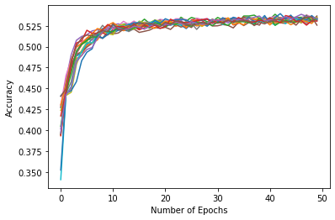

‘’’’

Parameters Section

"""""""""""""""""""""""""""""""""""""""""""""""""""""""""""""""""""""""""""

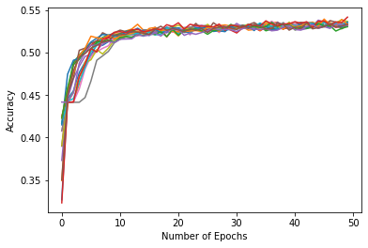

num_epochs =50

csv_file = 'winequality-white.csv'

num_cols = 11

num_cols_after = 11

[15, 20, 55, 175]

[0, 5, 35, 120]

[0, 5, 50]

[0, 5]

act_function = 'tanh'

activation2='sigmoid'

optimizer='Nadam'

set_verbose = 2Epoch 48/50

123/123 - 1s - loss: 1.1035 - accuracy: 0.5304 - val_loss: 1.0509 - val_accuracy: 0.5602

Epoch 49/50

123/123 - 1s - loss: 1.1044 - accuracy: 0.5316 - val_loss: 1.0511 - val_accuracy: 0.5480

Epoch 50/50

123/123 - 1s - loss: 1.1032 - accuracy: 0.5332 - val_loss: 1.0537 - val_accuracy: 0.5490

Time required for training: 0:10:11.928739

[[ 0 0 1 2 0 0]

[ 0 2 16 10 0 0]

[ 0 0 130 156 0 0]

[ 0 0 68 362 38 0]

[ 0 0 3 116 44 0]

[ 0 0 0 23 9 0]]

‘’’’’’’

num_epochs =100

csv_file = 'winequality-white.csv'

num_cols = 11

num_cols_after = 11

layer1_nodes = [15,75,115,300]

layer2_nodes = [0,15,30,45]

layer3_nodes = [0,15,15]

layer4_nodes=[0,15]

act_function = 'tanh'

activation2='sigmoid'

optimizer='Nadam'

set_verbose = 2

Epoch 98/100

123/123 - 1s - loss: 1.0645 - accuracy: 0.5485 - val_loss: 1.0222 - val_accuracy: 0.5735

Epoch 99/100

123/123 - 1s - loss: 1.0644 - accuracy: 0.5444 - val_loss: 1.0233 - val_accuracy: 0.5704

Epoch 100/100

123/123 - 1s - loss: 1.0631 - accuracy: 0.5439 - val_loss: 1.0229 - val_accuracy: 0.5684

Time required for training: 10:26:34.899969

[[ 0 0 1 2 0 0]

[ 0 3 19 6 0 0]

[ 0 0 171 114 1 0]

[ 0 0 94 335 39 0]

[ 0 0 7 108 48 0]

[ 0 0 1 23 8 0]]

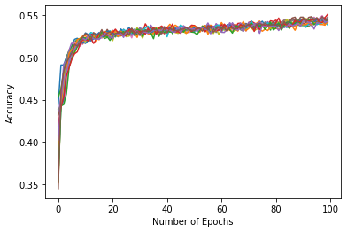

‘’’’’

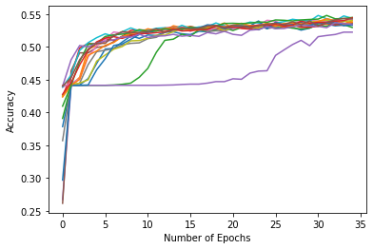

123/123 - 1s - loss: 1.0947 - accuracy: 0.5416 - val_loss: 1.0411 - val_accuracy: 0.5633

Epoch 34/35

123/123 - 1s - loss: 1.0938 - accuracy: 0.5436 - val_loss: 1.0369 - val_accuracy: 0.5714

Epoch 35/35

123/123 - 1s - loss: 1.0923 - accuracy: 0.5429 - val_loss: 1.0371 - val_accuracy: 0.5735

Time required for training: 0:07:23.593115

[[ 0 0 1 2 0 0]

[ 0 0 21 7 0 0]

[ 0 0 179 107 0 0]

[ 0 0 103 340 25 0]

[ 0 0 8 111 43 1]

[ 0 0 1 23 8 0]]

‘’’’

act_function = 'tanh'

activation2='sigmoid'

optimizer='Nadam'

set_verbose = 2

[90, 120, 160, 365]

[0, 30, 40, 205]

[0, 30, 40]

[0, 30]

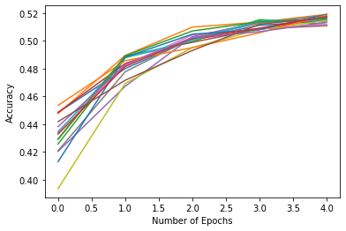

123/123 - 1s - loss: 1.1856 - accuracy: 0.4931 - val_loss: 1.0949 - val_accuracy: 0.5469

Epoch 4/5

123/123 - 1s - loss: 1.1586 - accuracy: 0.5120 - val_loss: 1.0827 - val_accuracy: 0.5388

Epoch 5/5

123/123 - 1s - loss: 1.1419 - accuracy: 0.5171 - val_loss: 1.0860 - val_accuracy: 0.5429

Time required for training: 0:01:13.955720

[[ 0 0 1 2 0 0]

[ 0 0 19 9 0 0]

[ 0 0 200 86 0 0]

[ 0 0 143 313 12 0]

[ 0 0 17 127 19 0]

[ 0 0 3 25 4 0]]

‘’’’

[90, 120, 160, 365]

[0, 30, 40, 205]

[0, 30, 40]

[0, 30]

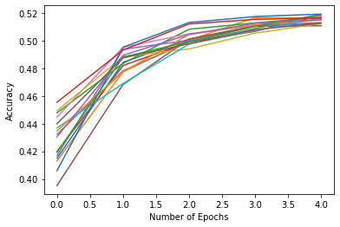

0.5255

Epoch 3/5

123/123 - 1s - loss: 1.1885 - accuracy: 0.4980 - val_loss: 1.1010 - val_accuracy: 0.5582

Epoch 4/5

123/123 - 1s - loss: 1.1660 - accuracy: 0.5082 - val_loss: 1.0917 - val_accuracy: 0.5408

Epoch 5/5

123/123 - 1s - loss: 1.1521 - accuracy: 0.5128 - val_loss: 1.0771 - val_accuracy: 0.5551

Time required for training: 0:01:15.281778

[[ 0 0 1 2 0 0]

[ 0 0 18 10 0 0]

[ 0 0 164 122 0 0]

[ 0 0 93 361 14 0]

[ 0 0 10 134 19 0]

[ 0 0 3 25 4 0]]

‘’’’

num_epochs =5

csv_file = 'winequality-white.csv'

num_cols = 11

num_cols_after = 11

layer1_nodes = [90,95,140,345]

layer2_nodes = [0,5,45,205]

layer3_nodes = [0,5,40]

layer4_nodes=[0,5]

act_function = 'tanh'

activation2='sigmoid'

optimizer='Nadam'

set_verbose = 2

‘’’’

Epoch 4/5

123/123 - 1s - loss: 1.2602 - accuracy: 0.4916 - val_loss: 1.1802 - val_accuracy: 0.5265

Epoch 5/5

123/123 - 1s - loss: 1.2327 - accuracy: 0.4980 - val_loss: 1.1555 - val_accuracy: 0.5296

Time required for training: 0:01:15.052303

[[ 0 0 1 2 0 0]

[ 0 0 16 12 0 0]

[ 0 0 180 106 0 0]

[ 0 0 129 339 0 0]

[ 0 0 16 147 0 0]

[ 0 0 3 29 0 0]]

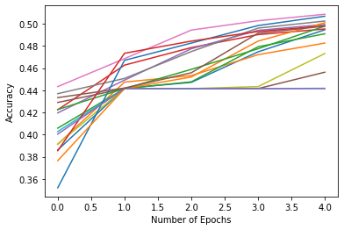

‘’’’’

[28, 77, 144, 265]

[0, 28, 77, 144]

[0, 28, 77]

[0, 28]

Epochs=3

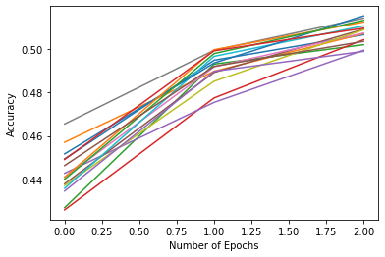

‘’’

123/123 - 1s - loss: 1.1927 - accuracy: 0.5028 - val_loss: 1.0997 - val_accuracy: 0.5347

Epoch 3/3

123/123 - 1s - loss: 1.1601 - accuracy: 0.5125 - val_loss: 1.1025 - val_accuracy: 0.5265

Time required for training: 0:00:51.566285

[[ 0 0 1 2 0 0]

[ 0 0 19 9 0 0]

[ 0 0 205 80 1 0]

[ 0 0 158 260 50 0]

[ 0 0 17 95 51 0]

[ 0 0 3 20 9 0]]

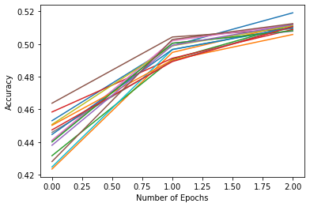

‘’’

num_epochs =2

csv_file = 'winequality-white.csv'

num_cols = 11

num_cols_after = 11

layer1_nodes = [50,55,75,250]

layer2_nodes = [0,5,25]

layer3_nodes = [0,5,25]

layer4_nodes=[0,5]

act_function = 'tanh'

activation2='sigmoid'

optimizer='Nadam'

set_verbose = 2

123/123 - 1s - loss: 1.6857 - accuracy: 0.3862 - val_loss: 1.4078 - val_accuracy: 0.4776

Epoch 2/2

123/123 - 1s - loss: 1.3827 - accuracy: 0.4416 - val_loss: 1.2976 - val_accuracy: 0.4776

Time required for training: 0:00:29.345276

[[ 0 0 0 3 0 0]

[ 0 0 0 28 0 0]

[ 0 0 0 286 0 0]

[ 0 0 0 468 0 0]

[ 0 0 0 163 0 0]

[ 0 0 0 32 0 0]]

‘’’’’’

num_epochs =10

csv_file = 'winequality-white.csv'

num_cols = 11

num_cols_after = 11

layer1_nodes = [50,65,115,235]

layer2_nodes = [0,15,50,120]

layer3_nodes = [0,15,25]

layer4_nodes=[0,15]

act_function = 'tanh'

activation2='sigmoid'

optimizer='Nadam'

set_verbose = 2

Epoch 9/10

123/123 - 1s - loss: 1.1336 - accuracy: 0.5245 - val_loss: 1.0639 - val_accuracy: 0.5500

Epoch 10/10

123/123 - 1s - loss: 1.1290 - accuracy: 0.5225 - val_loss: 1.0614 - val_accuracy: 0.5551

Time required for training: 0:02:13.206385

[[ 0 0 1 2 0 0]

[ 0 0 18 10 0 0]

[ 0 0 160 126 0 0]

[ 0 0 90 343 35 0]

[ 0 0 11 111 41 0]

[ 0 0 3 20 9 0]]

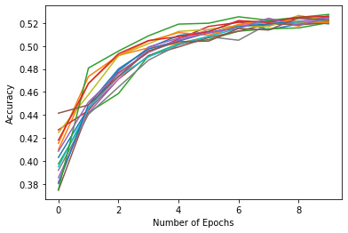

‘’’

num_epochs =50

csv_file = 'winequality-white.csv'

num_cols = 11

num_cols_after = 11

layer1_nodes = [50,65,115,235]

layer2_nodes = [0,15,50,120]

layer3_nodes = [0,15,25]

layer4_nodes=[0,15]

act_function = 'tanh'

activation2='sigmoid'

optimizer='RMSprop'

set_verbose = 2

123/123 - 1s - loss: 1.0974 - accuracy: 0.5316 - val_loss: 1.0419 - val_accuracy: 0.5704

Epoch 50/50

123/123 - 1s - loss: 1.0967 - accuracy: 0.5345 - val_loss: 1.0457 - val_accuracy: 0.5510

Time required for training: 0:07:13.473805

[[ 0 0 1 2 0 0]

[ 0 3 16 9 0 0]

[ 0 0 164 121 1 0]

[ 0 0 92 321 55 0]

[ 0 0 11 100 52 0]

[ 0 0 3 20 9 0]]

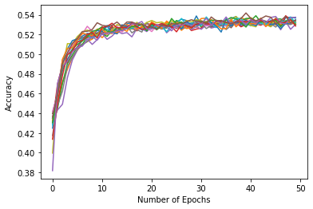

‘’’’’’

"""""""""""""""""""""""""""""""""""""""""""""""""""""""""""""""""""""""""""

num_epochs =50

csv_file = 'winequality-white.csv'

num_cols = 11

num_cols_after = 11

layer1_nodes = [50,75,125,315]

layer2_nodes = [0,25,50,190]

layer3_nodes = [0,25,25]

layer4_nodes=[0,25]

act_function = 'tanh'

activation2='sigmoid'

optimizer='RMSprop'

set_verbose = 2

0.5510

Epoch 49/50

123/123 - 1s - loss: 1.0977 - accuracy: 0.5263 - val_loss: 1.0519 - val_accuracy: 0.5510

Epoch 50/50

123/123 - 0s - loss: 1.0974 - accuracy: 0.5288 - val_loss: 1.0478 - val_accuracy: 0.5490

Time required for training: 0:07:11.964420

[[ 0 0 1 2 0 0]

[ 0 3 16 9 0 0]

[ 0 0 190 94 2 0]

[ 0 0 122 293 53 0]

[ 0 0 13 98 52 0]

[ 0 0 3 20 9 0]]

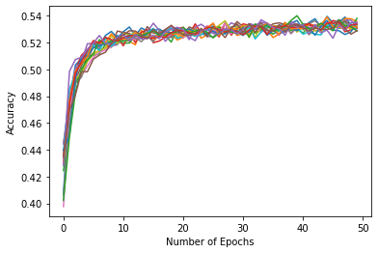

‘’’’’’

num_epochs =50

csv_file = 'winequality-white.csv'

num_cols = 11

num_cols_after = 11

layer1_nodes = [55,60,135,300]

layer2_nodes = [0,5,75]#,190]

layer3_nodes = [0,70,125]

layer4_nodes=[0,55]

act_function = 'tanh'

activation2='sigmoid'

optimizer='RMSprop'

set_verbose = 2

Epoch 48/50

123/123 - 1s - loss: 1.0663 - accuracy: 0.5429 - val_loss: 1.0242 - val_accuracy: 0.5704

Epoch 49/50

123/123 - 1s - loss: 1.0647 - accuracy: 0.5454 - val_loss: 1.0455 - val_accuracy: 0.5510

Epoch 50/50

123/123 - 1s - loss: 1.0646 - accuracy: 0.5401 - val_loss: 1.0285 - val_accuracy: 0.5837

Time required for training: 0:05:26.084643

[[ 0 0 1 2 0 0]

[ 0 3 19 6 0 0]

[ 0 0 185 101 0 0]

[ 0 0 102 361 5 0]

[ 0 0 7 133 23 0]

[ 0 0 2 25 5 0]]

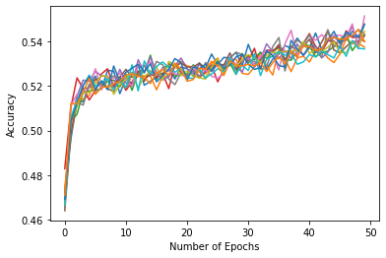

‘’’’

layer1_nodes = [55,60,135,360]

layer2_nodes = [0,5,75]#,190]

layer3_nodes = [0,70,135]

layer4_nodes=[0,65]

123/123 - 1s - loss: 1.0651 - accuracy: 0.5408 - val_loss: 1.0298 - val_accuracy: 0.5786

Epoch 49/50

123/123 - 1s - loss: 1.0633 - accuracy: 0.5447 - val_loss: 1.0262 - val_accuracy: 0.5571

Epoch 50/50

123/123 - 1s - loss: 1.0607 - accuracy: 0.5413 - val_loss: 1.0284 - val_accuracy: 0.5582

Time required for training: 0:05:23.221477

[[ 0 0 1 2 0 0]

[ 0 0 20 8 0 0]

[ 0 0 162 123 1 0]

[ 0 0 89 335 44 0]

[ 0 0 6 107 49 1]

[ 0 0 0 23 8 1]]

‘’’’’’

num_epochs =100

csv_file = 'winequality-white.csv'

num_cols = 11

num_cols_after = 11

layer1_nodes = [55,60,135,330]

layer2_nodes = [0,5,75]#,190]

layer3_nodes = [0,70,125]

layer4_nodes=[0,50]

act_function = 'tanh'

activation2='sigmoid'

optimizer='RMSprop'

set_verbose = 2

Epoch 98/100

123/123 - 1s - loss: 1.0205 - accuracy: 0.5625 - val_loss: 0.9989 - val_accuracy: 0.5888

Epoch 99/100

123/123 - 1s - loss: 1.0204 - accuracy: 0.5595 - val_loss: 1.0041 - val_accuracy: 0.5765

Epoch 100/100

123/123 - 1s - loss: 1.0177 - accuracy: 0.5613 - val_loss: 1.0223 - val_accuracy: 0.5500

Time required for training: 0:10:32.791830

[[ 0 0 1 1 1 0]

[ 0 2 20 6 0 0]

[ 0 1 192 83 10 0]

[ 0 0 118 247 102 1]

[ 0 0 10 54 97 2]

[ 0 1 2 10 18 1]]

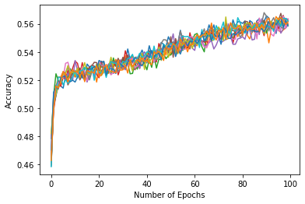

‘’’’’

Epochs 150

123/123 - 1s - loss: 0.9876 - accuracy: 0.5702 - val_loss: 0.9870 - val_accuracy: 0.5908

Epoch 149/150

123/123 - 1s - loss: 0.9879 - accuracy: 0.5778 - val_loss: 0.9964 - val_accuracy: 0.5806

Epoch 150/150

123/123 - 1s - loss: 0.9863 - accuracy: 0.5778 - val_loss: 0.9981 - val_accuracy: 0.5827

Time required for training: 0:16:10.329149

[[ 0 0 1 2 0 0]

[ 0 3 22 3 0 0]

[ 0 1 192 93 0 0]

[ 0 2 120 325 21 0]

[ 0 1 12 99 50 1]

[ 0 1 2 18 10 1]]

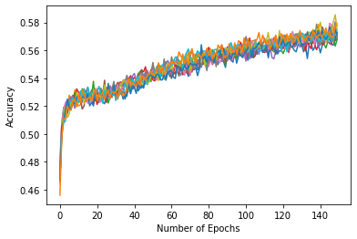

layer4_nodes=[0,15]

act_function = 'tanh'

activation2='sigmoid'

optimizer='RMSprop'

set_verbose = 2

.582-.5778= .0042 *** <- good

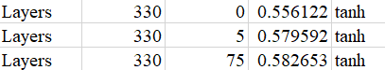

‘’’’’

num_epochs =100

csv_file = 'winequality-white.csv'

num_cols = 11

num_cols_after = 11

layer1_nodes = [100,105,175,325]

layer2_nodes = [0,5,70]#,190]

layer3_nodes = [0,65,80]

layer4_nodes=[0,15]

‘’’’

123/123 - 1s - loss: 1.0065 - accuracy: 0.5671 - val_loss: 1.0066 - val_accuracy: 0.5806

Epoch 198/200

123/123 - 1s - loss: 1.0074 - accuracy: 0.5699 - val_loss: 1.0073 - val_accuracy: 0.5673

Epoch 199/200

123/123 - 1s - loss: 1.0074 - accuracy: 0.5684 - val_loss: 1.0025 - val_accuracy: 0.5765

Epoch 200/200

123/123 - 1s - loss: 1.0066 - accuracy: 0.5671 - val_loss: 1.0166 - val_accuracy: 0.5755

Time required for training: 0:23:22.721556

[[ 0 0 1 2 0 0]

[ 0 4 18 5 1 0]

[ 0 3 164 113 6 0]

[ 0 0 85 341 42 0]

[ 0 0 6 103 54 0]

[ 0 0 1 20 10 1]]

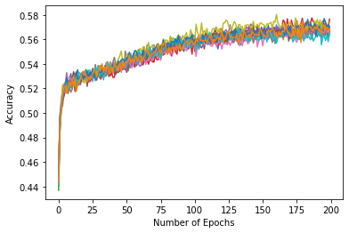

----

num_epochs =200

csv_file = 'winequality-white.csv'

num_cols = 11

num_cols_after = 11

layer1_nodes = [15, 20, 55, 175]

layer2_nodes = [0,5,35]#,180]

layer3_nodes = [0,5,50]

layer4_nodes=[0,45]

act_function = 'tanh'

activation2='sigmoid'

optimizer='RMSprop'

set_verbose = 2

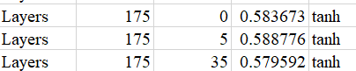

Epoch 198/200

123/123 - 1s - loss: 1.0049 - accuracy: 0.5613 - val_loss: 1.0055 - val_accuracy: 0.5633

Epoch 199/200

123/123 - 1s - loss: 1.0049 - accuracy: 0.5697 - val_loss: 0.9970 - val_accuracy: 0.5735

Epoch 200/200

123/123 - 1s - loss: 1.0023 - accuracy: 0.5702 - val_loss: 1.0004 - val_accuracy: 0.5796

Time required for training: 0:24:12.761606

[[ 0 0 1 2 0 0]

[ 0 2 19 7 0 0]

[ 0 1 153 130 2 0]

[ 0 0 79 357 32 0]

[ 0 0 4 103 55 1]

[ 0 0 2 18 11 1]]

‘’’’

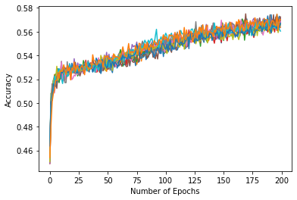

‘’’’

[15, 20, 55, 175]

[0, 5, 35]

[0, 5, 50]

[0, 45]

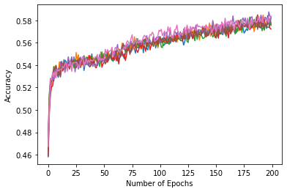

‘’’’’

num_epochs =200

csv_file = 'winequality-white.csv'

num_cols = 11

num_cols_after = 11

layer1_nodes = [105, 110, 165,285,315]

layer2_nodes = [0,5,55]#,120]

layer3_nodes = [0,50,65]

layer4_nodes=[0,15]

act_function = 'tanh'

activation2='sigmoid'

optimizer='RMSprop'

set_verbose = 2

‘’’’

num_epochs =200

csv_file = 'winequality-white.csv'

num_cols = 11

num_cols_after = 11

layer1_nodes = [105, 110, 125,175,315]

layer2_nodes = [0,5,15]#,120]

layer3_nodes = [0,5,10,30]

layer4_nodes=[0,5]

act_function = 'tanh'

activation2='sigmoid'

optimizer='RMSprop'

set_verbose = 2